**Amazon Pantry**

**TASK – 1**

**1. IDENTYFYING STAKEHOLDERS**

|  |  |
| --- | --- |
| **ACTOR** | **What he can do on the Software Created** |
| Customer | ● Register and login to system.  ● View different categories of essential and non-essential items.  ● View advertisements and offers.  ● Select the items.  ● Add items to shopping cart.  ● View total shopping cart.  ● Choose payment method. |
| Delivery Man | • Check the list of delivery order to the desired location.  • Close the order after delivery. |
| Tester | • Tester will test the before deployment. |
| Business Analyst | • Ensure all the requirements were cover and check communication between all the stakeholders. |
| Management | • View reports at the end of the day.  • View monthly Sales and Revenue.  • View feedback and customers satisfaction. |

**2. As-Is Flowchart**

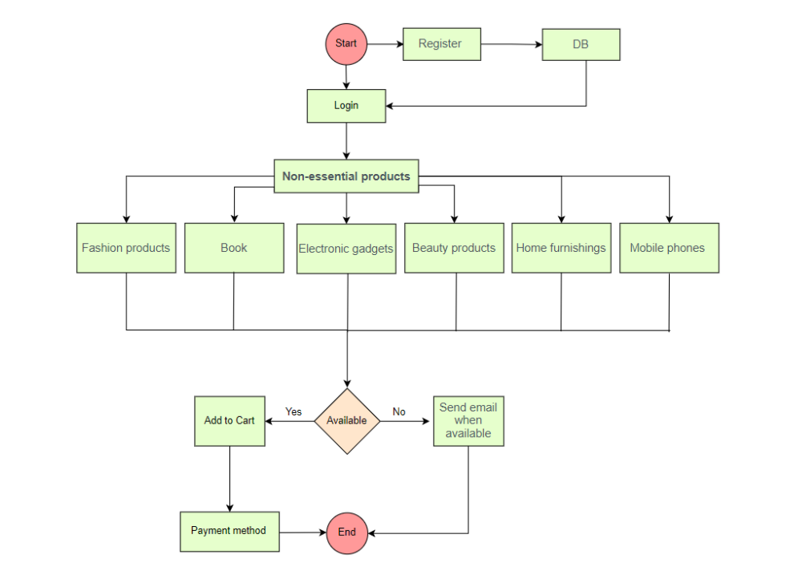

**Future State Flowchart**

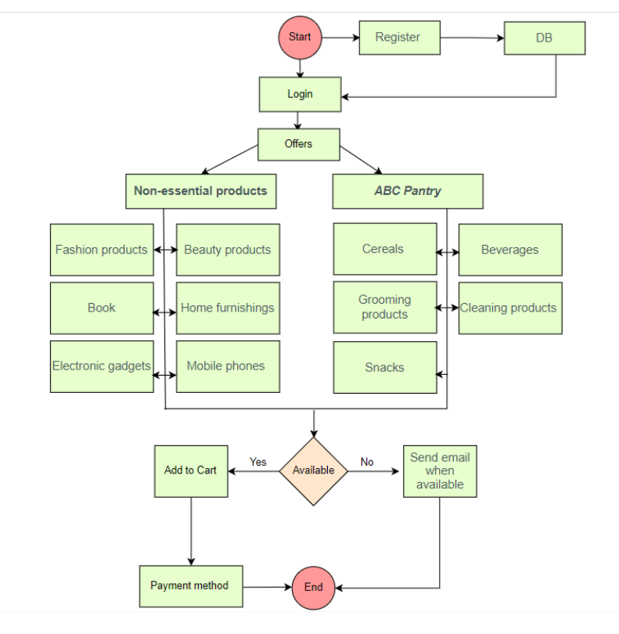

**3. Scope of the ABC Pantry and main features**

• Add more items based on customers need.

• Add pick up option for the order.

• Send adv and offers for customers by email.

• Add cancel option for order.

• Items should be arranged in ascending and descending Order.

• For pantry order should be deliver in shortest time.

**4. In-scope and Out of Scope for Restaurant Management Software**

**in-scope**

• Register and login to system.

• View different categories of essential and non-essential items.

• View advertisements and offers.

• Select the items and add it to shopping cart.

• View total shopping cart.

• Choose payment method.

• No order of an amount less than 30 USD.

• Free Delivery if the total order exceeds 50 USD.

• Generate report.

**out-of-scope**

• The system will not be able to register a new customer to the system.

• Facilities for people with special needs.

• Discount for second order.

• Membership.

**5. Business Requirements both Functional and Non-Functional Requirements**

**functional Requirements**

• User should be able to register and login to the system.

• The system should keep records of different categories of items.

• The system should have new feature known as ABC Pantry.

• The system should have logical grouping of products.

• The system should have five advertisements.

• The system should have a feature to show certain offer.

• User should be able to add items to shopping cart.

• The system should not allow the user to place an order of an amount less than 30 USD.

• The system should have Free Delivery only if the total order exceeds 50 USD.

• The system should generate reports at the end of the day.

• Total sales for each day

• Total sales for each product category as mentioned in point four.

• Total sales across USA

• Total sales for each city.

• Total sales for each zone that city falls into (that is, zone 1, 2, 3, and 4)

• Identify best-selling categories

• Identify the worst-selling categories

• Total sales of each week city wise

• Identify which day of the week shows highest booking by customers

**Non-functional Requirements**

• Highly secure, scalable, and reliable

• The screens should be self-explanatory and very user friendly.

• System should be had regular maintenance.

• The site should load in 3 seconds.

• Data should be stored in cloud

**6. Mock Screens**

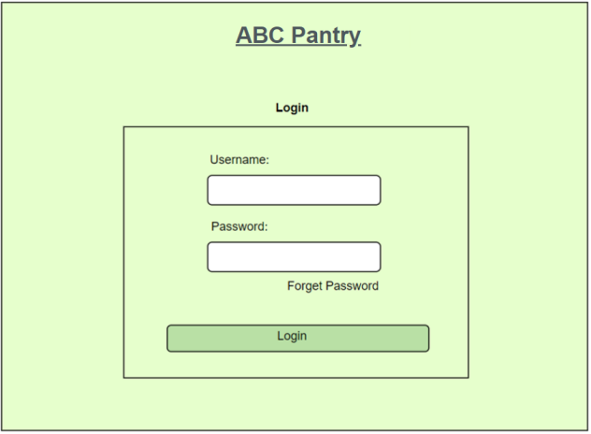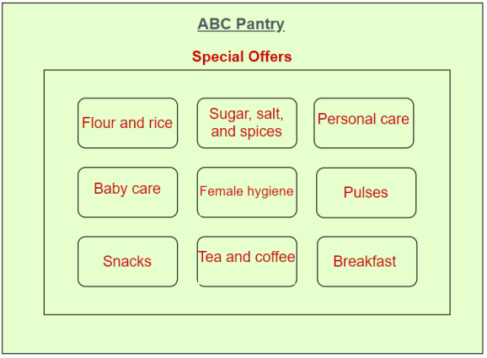

**TASK – 2**

**1. Make a product backlog of user stories for the given case study. User Stories should be in the format of As a <type of user>, I want <goal> so that <reason>**

**2. For each story, write the acceptance criteria.**

|  |  |
| --- | --- |
| **Product Backlog** | **Acceptance Criteria** |
| As a user I want to create an account so that I can use ABC shopping. | The user can access the application with valid information otherwise no account created. |
| As a user I want to reset password so that I can change password if I don’t remember. | A user is able to change password if he does not remember password or he want to change it so if he remembers old password or send link to reset new password. |
| As a user I want to search the items so that I can lookup items and prices. | A user is able to enter specific items on search option and find the items. |
| As a user I want to view shopping cart so that I can check and modify my order. | A user is able to view shopping cart and he can edit/delete items. |
| As items collector I want an accurate order data so that I can easily find items and their quantity. | As items collector is able to view order and their quantity. |
| As delivery man I want to view the orders and locations to easy delivery. | A delivery man is able to view orders and their locations. |
| As Management I want sales reports at end of the day so that I can make decision. | The management are able to generate sales report. |

**TASK – 3**

**1. Create a dashboard for senior management for Chicago to view sales of personal care products for the last 6 months. Make assumptions as appropriate and create the dashboard using your own mock data. For any missing data make your assumptions to create mock data. Write down the assumptions as well.**

For personal care product we notice that March and April were the highest sales and May was the lowest sale.

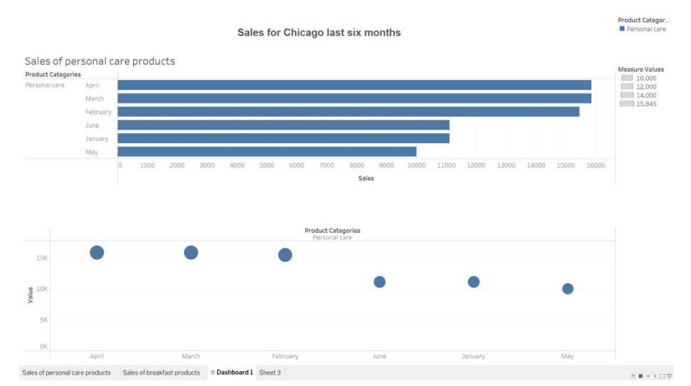

**2. Create a dashboard to show Senior Management for Chicago to view sales of breakfast products for the last six months. Make assumptions as appropriate and create the dashboard using your own mock data. For any missing data make your assumptions to create mock data. Write down the assumptions as well.**

For breakfast product we notice that January was the highest sales and April was the lowest sale.

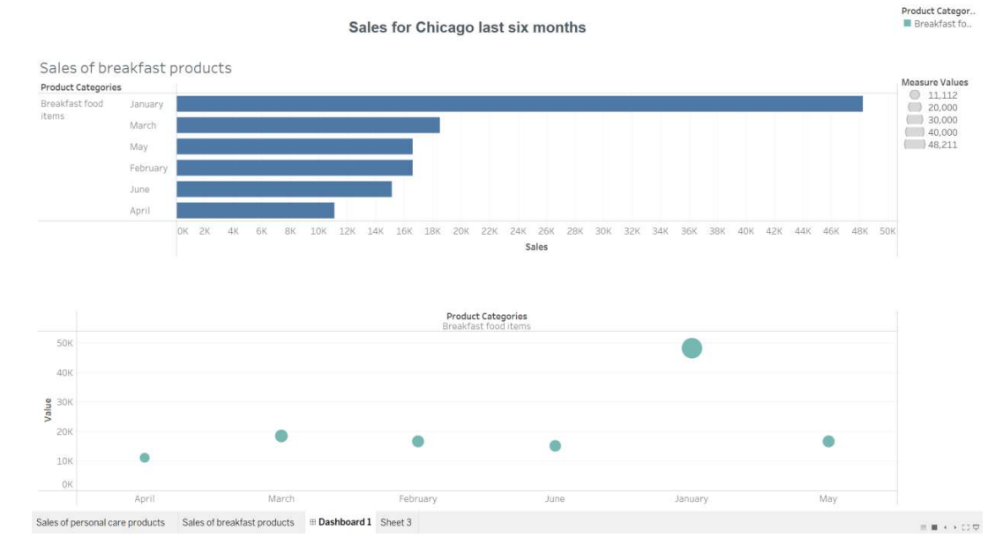

Dashboard that clarifies the sales of personal care and breakfast product

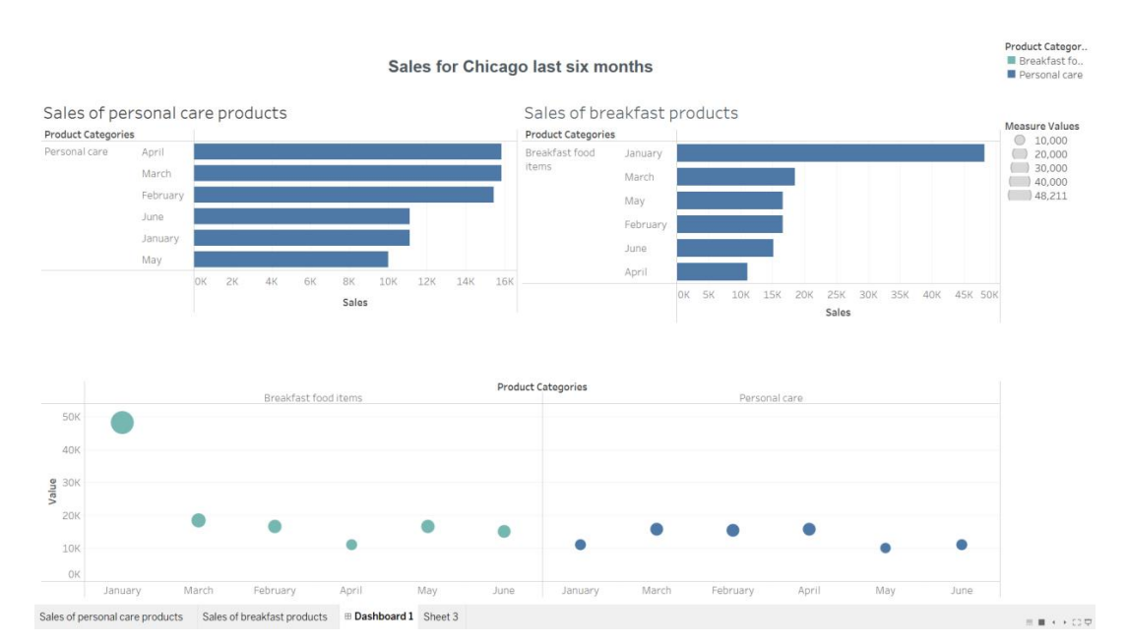

**TASK – 4**

**Question 1:**

1. **Create a bar graph showing the sales. Label the chart correctly so that senior management gets a clear report of sales.**

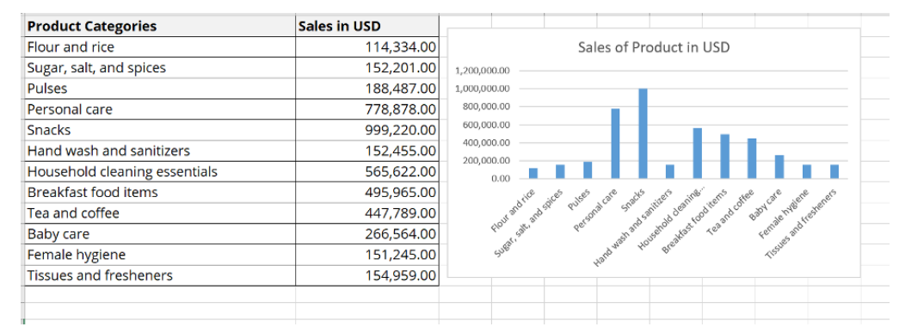

1. **Arrange the data above in excel in ascending and descending order.**

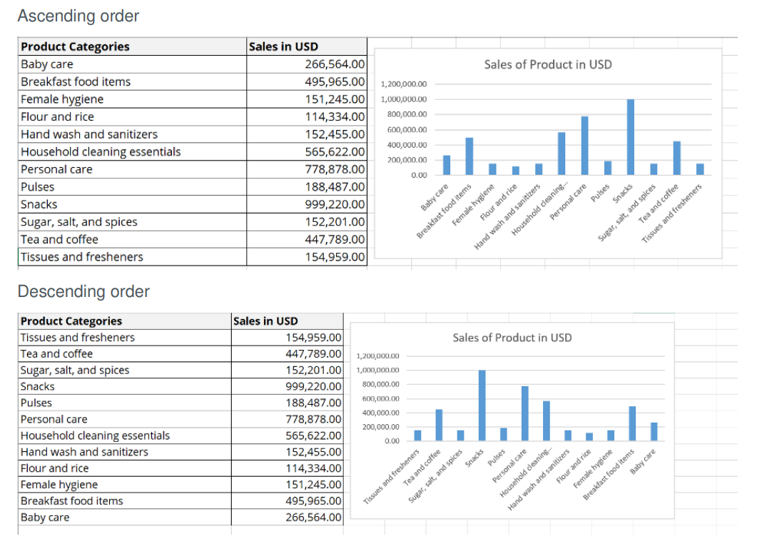

**Question 2**

1. **Create bar graphs of sales for zone 1 cities**

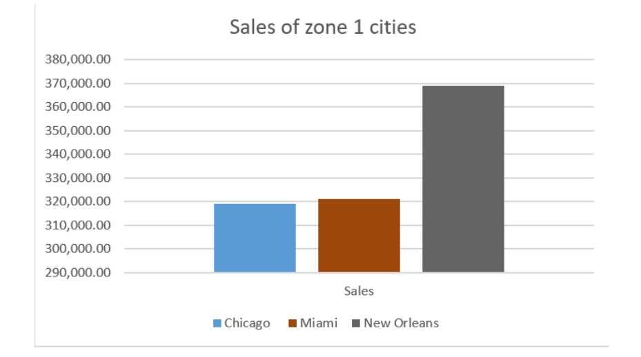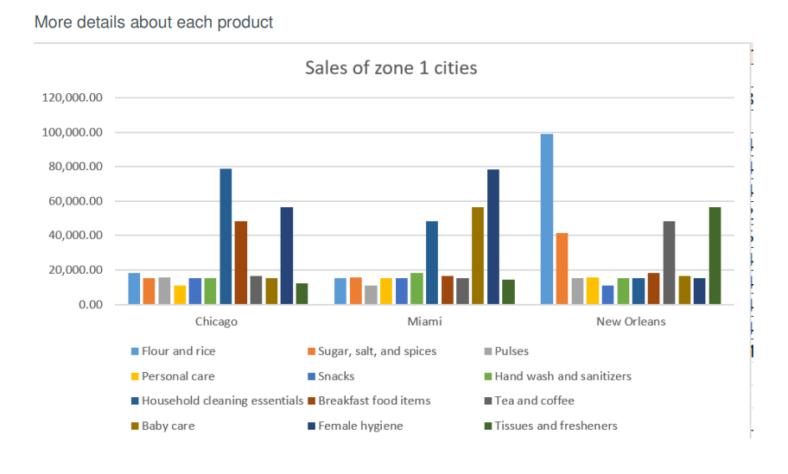

1. **Find total sales across all cities**

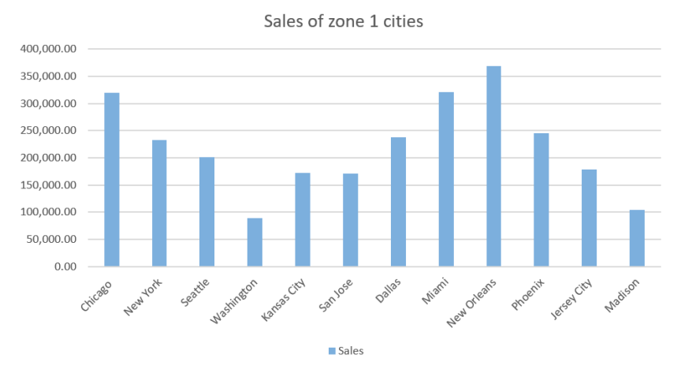

**Question 3**

1. **Using vlookup for product code HS, find sales in Phoenix**

=VLOOKUP(B8,B3:N14,11,FALSE) = 1,544.00

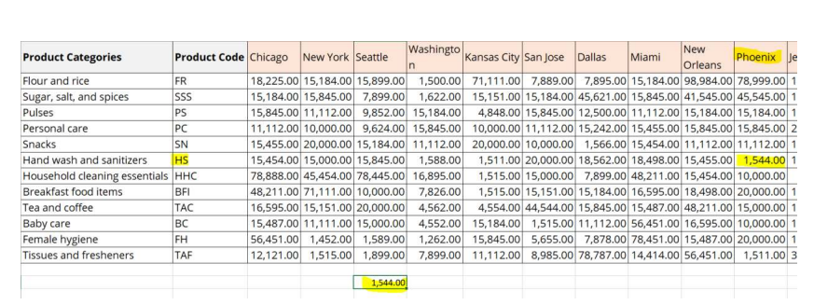

1. **Using vlookup for product code FR, find sales in Dallas**

=VLOOKUP(B3,B3:N14,8,FALSE) = 7,895.00

